Assignment 2: Flowchart Creation - Design a  
flowchart that outlines the logic for a user login process. It should include  
conditional paths for successful and unsuccessful login attempts, and a loop  
that allows a user three attempts before locking the account.

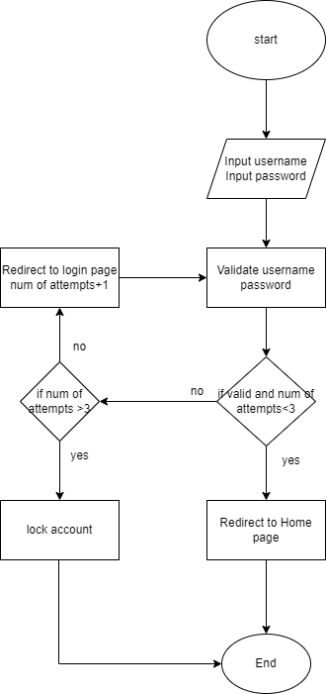

Function Main

Declare attempts

While attempts < 3

Output “Enter username”

Input username

Output “Enter password”

Input password

If Username && Password is Valid

Output “login successful”

End loop

Else

Output “Invalid Username or password”

Attempts +1

If attempts> 3

Lock=true

End if

End if

End Loop

End